Design Support documents



**Frame**

***Objectives***

Sed id semper diam, ut efficitur lorem. Pellentesque non nibh nisi. Quisque eget leo dictum, convallis leo non, imperdiet ex. Maecenas a metus orci. Praesent tortor dolor, semper id accumsan nec, vehicula ac mauris.

***Conception steps***

Lorem ipsum dolor sit amet, consectetur adipiscing elit. Mauris pulvinar, lectus quis condimentum fermentum, metus nisl congue lorem, id varius diam turpis nec tellus. Nam id vestibulum leo. Quisque

***Assumptions***

* Lorem ipsum dolor sit amet
* consectetur adipiscing elit.
* Mauris pulvinar

Quisque porttitor ligula ligula, vel pellentesque dui convallis a. Morbi id lorem eget arcu dapibus dapibus malesuada ac diam. Interdum et malesuada fames ac ante ipsum primis in faucibus.

***Simulations steps overview***

Sed id semper diam, ut efficitur lorem. Pellentesque non nibh nisi. Quisque eget leo dictum, convallis leo non, imperdiet ex. Maecenas a metus orci. Praesent tortor dolor, semper id accumsan nec, vehicula ac mauris. Maecenas maximus mauris est, ut dignissim arcu blandit id. Ut a tincidunt dolor. Nullam at ex eros.

Il faut pouvoir apporter un document illustratif pour les questions ci-dessous, c’est-à-dire les trucs surlignés en orange.

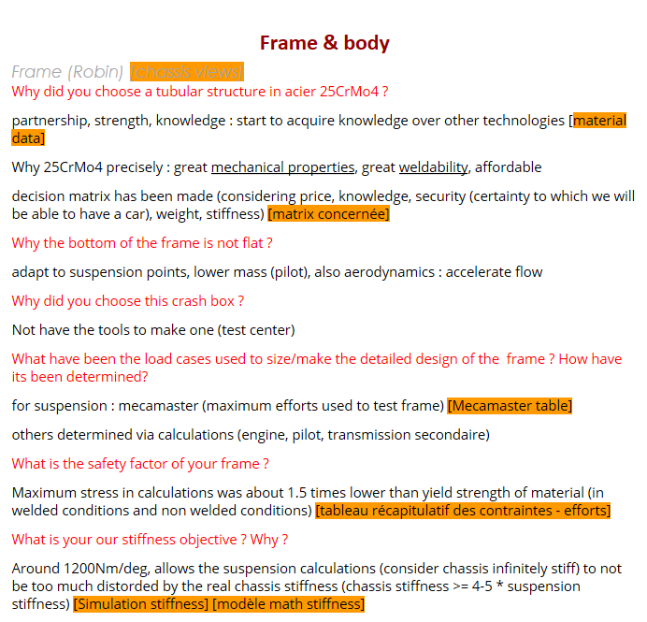

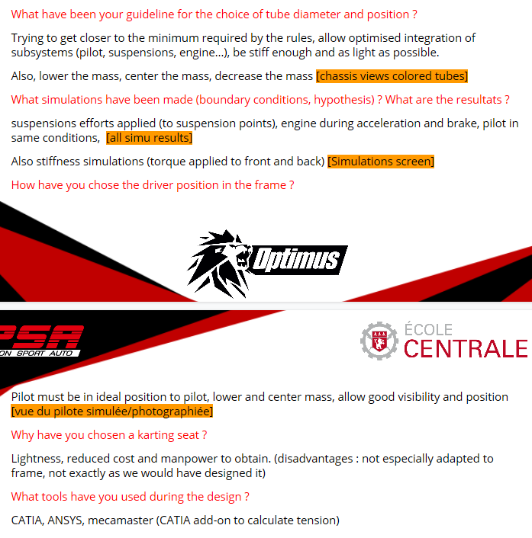

Loads table

Table of all mecamaster loads applied to frame

Simulation tests results

NB: Except for torsion, all load cases come from MécaMaster

Figure 1: Torsion

Figure 2a: Acceleration 0.77g

Figure 2b: Acceleration 0.77g

Figure 3a: Braking 2g

Figure 3b: Braking 2g

Figure 4a: Bump 3g

Figure 4b: Bump 3g

Figure 5a: Left turn 2g

Figure 5b: Left turn 2g

Figure 6a: Left turn 1g + braking 1g

Figure 6b: Left turn 1g + braking 1g

Stiffness measure experiment

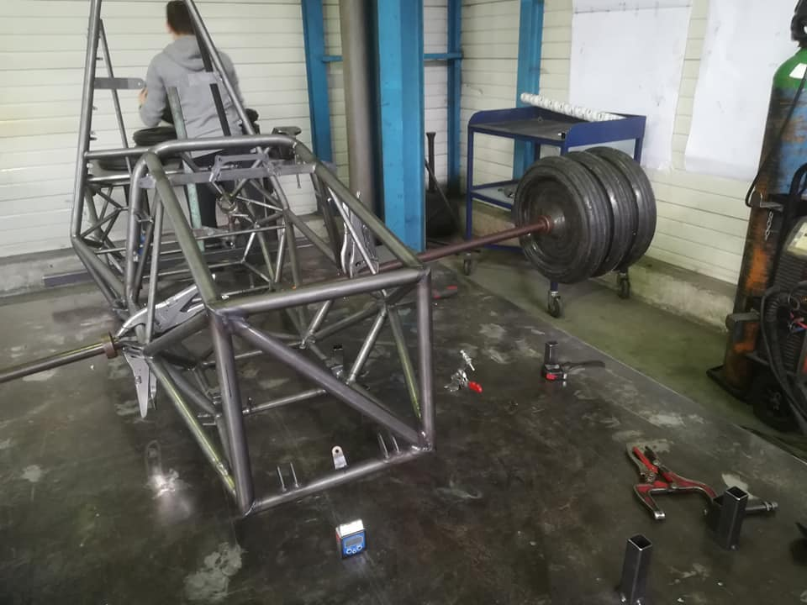 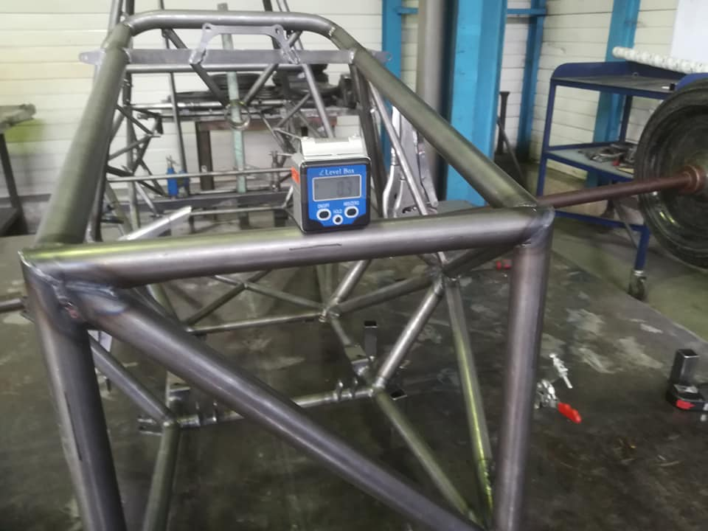

Figure 7: Stiffness measurement on the frame

Measure performed in two times:

* Apply a torque to the front and the cockpit of the frame, blocking the back
* Apply a torque at the back, blocking the front

The difference between the simulated and the measured values may come from the boundaries conditions that are not exactly the same.

Ecrire nos résultats des tests en torsion

Equipment positioning

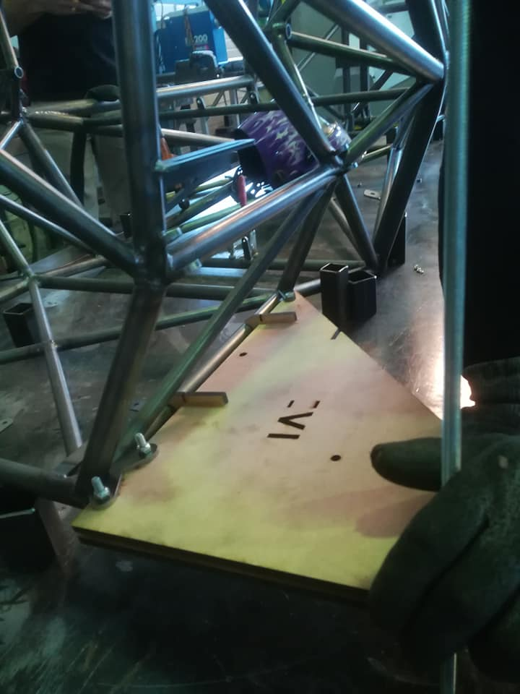

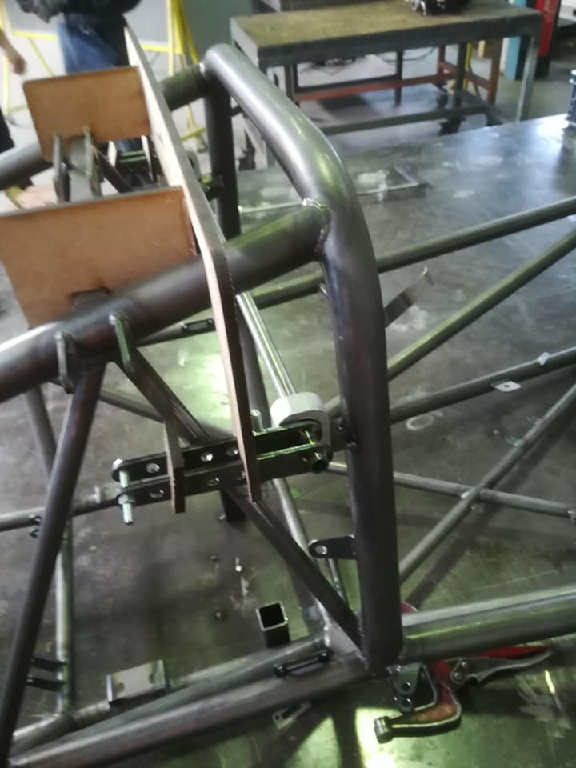 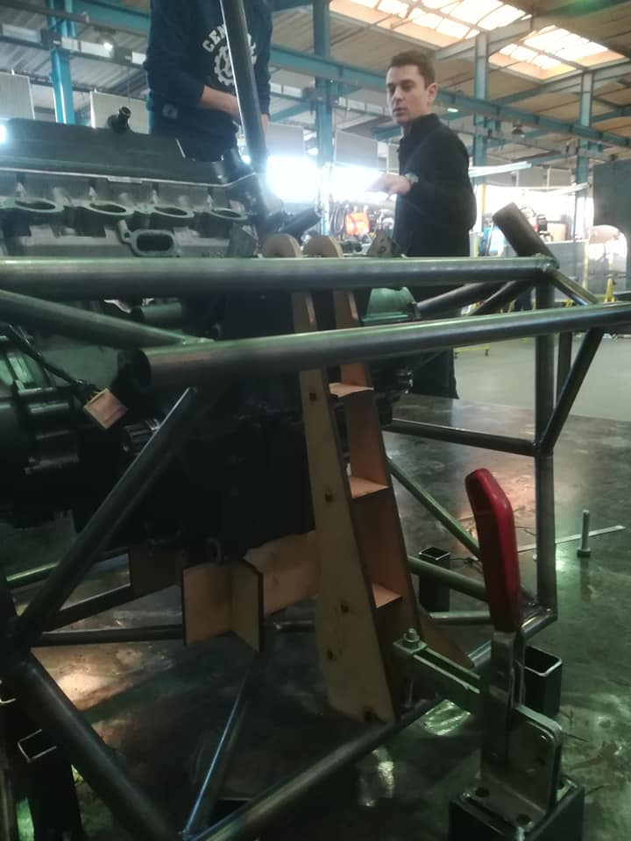 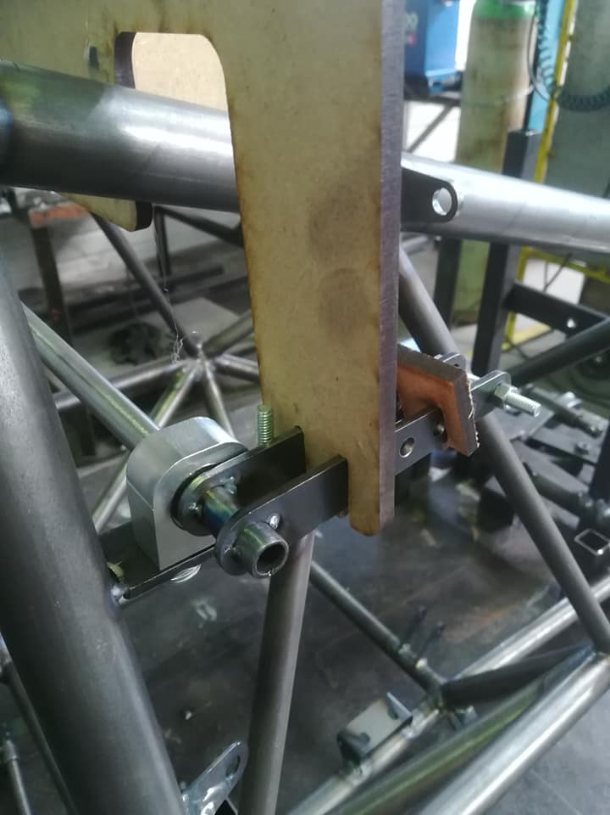

*Figure 8: Use of templates to precisely position equipments during welding*

Pilot position

Figure 10: Human model in CAD model to help designing the chassis

Tensile strength test results

Résumé tests traction A2M

Photo des échantillons ?

Appendix

Stiffness model (coefficient 𝛼)

Frame: 3 series torsion springs

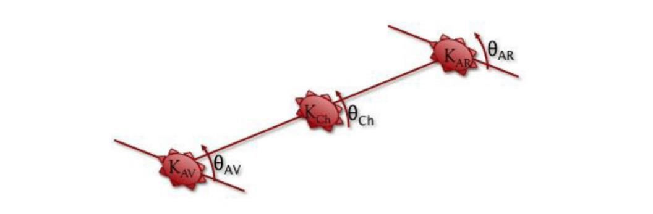

Figure 9: Definition of the model

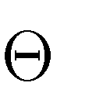Where K=stiffness and =angle. We also define 𝐾𝑇 and 𝜃𝑇 respectively the stiffness and the angle of the car.

In order to simplify the equations, we suppose 𝐾𝐴𝑉 = 𝐾𝐴𝑅; . 𝐾𝐴𝑉 = 𝐾𝑇 𝑎𝑛𝑑 𝜃𝐴𝑉 = 𝜃𝐴𝑅. It gives us the following equations:

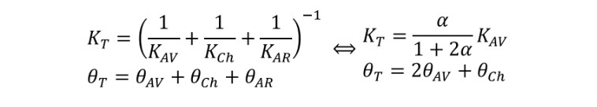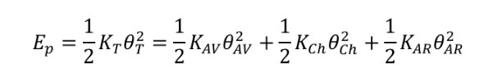

Finally,

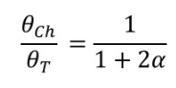

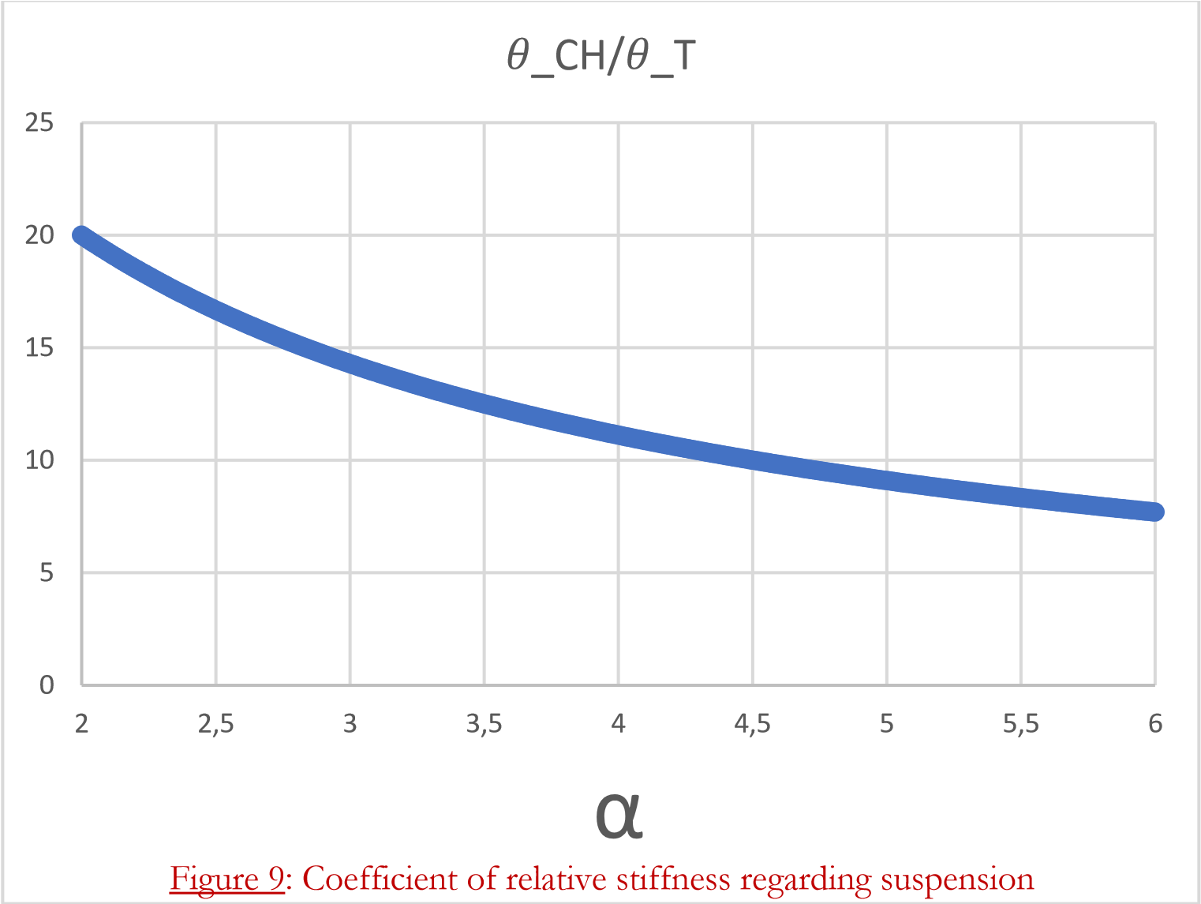

Coefficient of relative stiffness regarding suspension

If we want to keep 𝜃𝐶𝐻/𝜃𝑇 between 10% and 15%, we have to take α between 3 and 5.